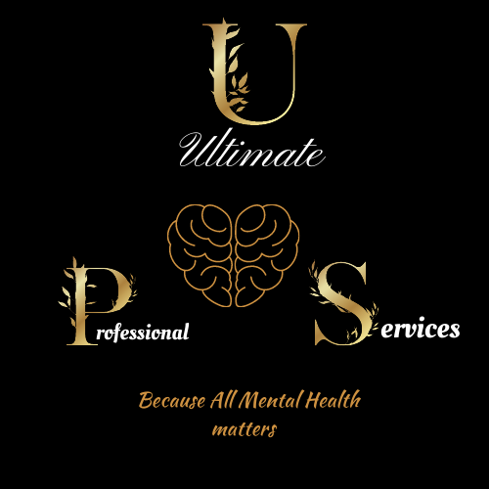
Ultimate Professional Services

TREATMENT CONSENT

I, ___________________________________, (Client) am providing consent for
______________________________________(Provider) to receive a mental health

evaluation and corresponding treatment from Ultimate Professional Services.

I/we understand the following:
- That I/we will be fully informed about the nature of the treatment, the risks and benefits, and the available treatment options. o That I/we will have the opportunity to have all questions answered to my/our satisfaction.
- That this consent is given voluntarily. o That I am legally competent and have the authority to provide consent for treatment.
- That I have the right to withdraw my consent for this treatment at any time.
- That withdrawing consent for this treatment will not prejudice my continued treatment relationship.

______________________________________________ ___________
Patient signature Date

______________________________________________ ___________
Parent/legal guardian Date

______________________________________________ ___________
Treatment provider Date

